Welcome Club – Perseverance 3 – Using Self Control
Staff contact: Megan 916-937-1365
Materials
General | Masks, Clip board, snack, water, name tag, hand sanitizer, pens, pencils, markers, check-in sheet
Balloon toss | balloons 2+ colors
Oreo Face | Oreo snack packs, wipes
Self-Control Board game | Game pieces, directions, teacher guide
Homework | Homework box, pencils, markers

Objective
Students will be able to Demonstrate an understanding of Self-Control.

Welcome Students – 10 minutes
*Boys and girls will check-in at separate classrooms.

- 1 Coach instructs students to line up outside and takes attendance. Be prepared to add new students to the roster. Ask the new student their first name, last name, grade and teacher’s name (if they do not know their teacher’s name that’s ok but the first 3 are a must).
- Remaining Coaches unstack chairs and prep group tables. We will be passing out snacks as students walk in, direct them to their table, etc. Once snacks have been passed out, please put the remaining snacks away for the day. (“Extra” snacks tend to be a distraction to students when left out and available.)
Prompt Questions: Use the questions below to start conversation.
What does it mean to help someone? Do you ever help your friends?
Are there different kinds of help? How have you helped someone this week?
________________________________________________________________________________________________
Welcome: Lead Coach
1st “Welcome to Welcome Club! Today we have a really fun day planned for you! Who remembers what we learned last week? (Listening, and maybe repeat the definition of Equity) Who remembers what Equity means? (See definition above). Today we are going to talk about Self-control. Who can tell me what self-control means? Yes, self-control is stopping and thinking before you do something or stopping yourself before you say something unkind or do something you shouldn’t do.” If something is upsetting us we can first, STOP and take a deep breath. (Write the word stop on the board). Then after we have calmed down we can THINK of how you feel and what to do. Finally, you can GO with your best choice.
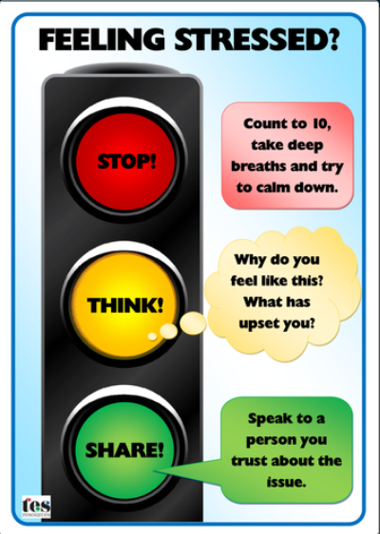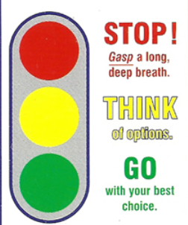
Let’s practice STOP-THINK-GO.
- Someone says a bad word to you. What should you do first? Stop take a breath, think what can I do, Go with the best option.
- You are playing tag on the playground. Someone tags you and it makes you fall on the ground. STOP-THINK-GO
- Your teacher is angry at you because you didn’t finish your homework. STOP-THINK-GO
- You really want to go play with your friends but your mom says you have to stay home and do chores. STOP-THINK-GO
2nd Now we are going to go outside and play a game but first we need to go over our Welcome Club Agreements! (Use “Four Squares of Treatment” to go over how we treat each other, etc. and transition into next section)
3rd It is time to clean up our snack! First table with clean desks and quiet arms get to go outside first!
Materials: name tags, sign in sheet, pens

Activity: Balloon Tap – 15 to 20 minutes
Student will need to listen to the instructions of the coach and follow directions.

***This activity will promote waiting and listening to instructions. The students will need to demonstrate self-control by letting others take the lead***
Lead Coach: Explains how to play the game.
Arrange students in a circle and assign alternating students to 2 teams (one student is team 1, the next student is team 2, the next student is team 1, and so forth). Alternative have the student were pennies and call out colors
- Fill the circle with balloons.
- Call “Team 1!” Only students on team 1 should tap the balloons.
- Switch to Team 2, and only students on Team 2 should tap the balloons.
- Continue switching on a 20-30 second interval. Students will really have to listen for the auditory cue to signify that it’s their team’s turn to tap.
- OPTIONAL: Use multicolored balloons. Call out the “off-limits color” and no one should tap any balloon of that color. Then switch colors!

Table Coach: Be a player in the game.
- Make sure balloons stay in the circle.
- Encourage students to participate
- Be energetic about the game.
Materials: balloons 2+ colors, pennies

Activity: Oreo Face– 20 minutes
*****Students are going to practice self control and problem solving by trying to eat the Oreo and move the Oreo from their face. ****
Lead Coach: explains how to do the activity.
- Every person gets one pack of Oreos to try the game.
- Place 1 Cookie on your forehead. Using only your face try to get the Oreo in your mouth.
- Students are given a pack of 2 or 4 Oreos. They can try again up to 4 times.

Co-Coach: join in and make sure your table understands how to play.
- Each student at your table gets their own pack of cookies.
- Throw away cookies that fall on the floor.
- Make sure students not currently playing cheer on their table mates.
***Give each students a baby wipe before and after the game to wipe their face.***

Discussion Questions:
- Was getting the Oreo to your mouth hard?
- What is the best way to win the Oreo Challenge?
- Did you change the way you were trying/your strategy?
- When you figured it out did you help your friends?
- This was a really silly problem of trying to eat the cookie with no hands. What problems to you find at school? How do you try to solve those problems?

Minute to win it explanation of the game

Materials: Oreo snack packs, wipes

Activity: Board game– 20 minutes
*****Students are going to practice self control and problem solving solutions by playing the board game and thinking through situation. ****
Lead Coach: explains how to do the activity.
- Directions below
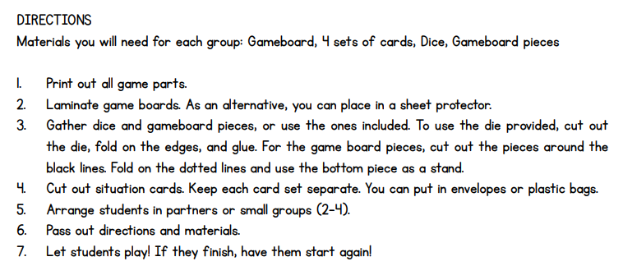

Co-Coach: join in and make sure your table understands how to play.
- Student direction will be given to each group and are attached on TIF

Materials: game and pieces

Homework – 40 minutes
We will have printed out some worksheets for the students to work on. They are categorized by grade level and subject.
Students will focus on working on their homework for the day.
Transitioning to homework time can be difficult...all coaches should work together to ensure students are moving to desks, pulling out their homework, or picking a worksheet from the folder. Pick a couple of students to sit with and assist them during homework time.

- Coaches: Give any help to students when asked. Help them work out any struggles they might have

- Tutor tips:
    - Don’t give the answer to the students - help them work it out together.
  - MATH: use visuals to help them see the problem more clearly; Help them spot key words in word problems and how to solve it
  - LITERATURE/ENGLISH: help them sound out difficult words; if they are struggling and do not know the word, give them synonyms and give them a push to right direct

Clean Up– 5 minutes
Instruct students to pick up and throw away trash before they leave.
- Pick up and throw away trash.
- Sweep floor
- Clean up WC supplies

Please fill out this Survey: https://forms.office.com/r/r1kpc21QTh

